2.Write the python program to solve 8-Queen problem
AIM:
To write a Python program to solve the 8-Queen problem using backtracking.

Objective:
To place eight queens on an 8×8 chessboard so that no two queens attack each other.
Algorithm:
- Start with the first row.
- Place a queen in a safe column.
- Check whether the queen is safe (no queen in the same column or diagonal).
- If safe, place the queen and move to the next row.
- If no safe position is found, backtrack to the previous row.
- Repeat until all eight queens are placed.
- Display the chessboard.
- Stop.
Flowchat:
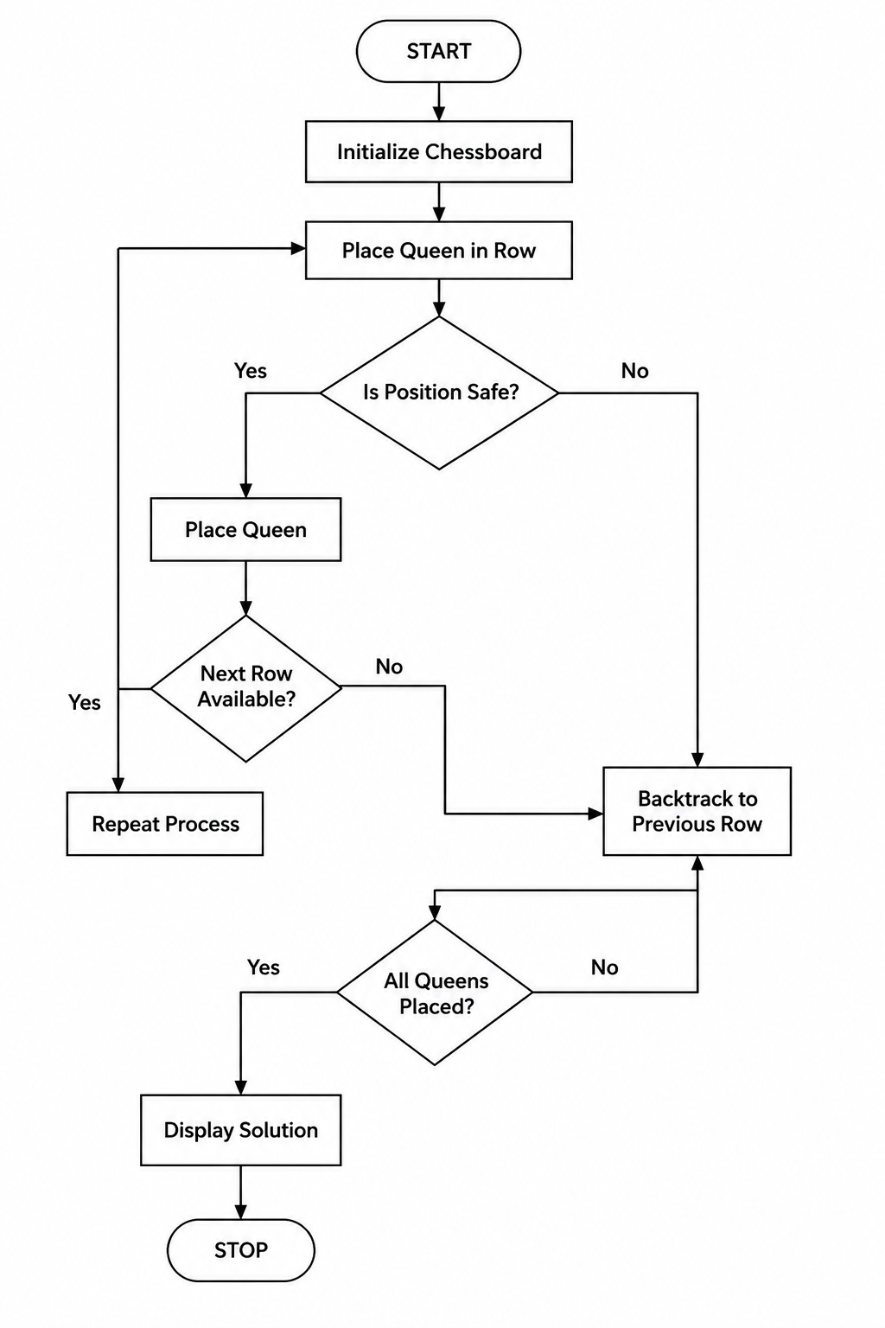

Code:
N = 8

board = [[0]*N for _ in range(N)]

def safe(row, col):
for i in range(row):
if board[i][col]:
return False

i, j = row-1, col-1
while i >= 0 and j >= 0:
if board[i][j]:
return False
i -= 1
j -= 1

i, j = row-1, col+1
while i >= 0 and j < N:
if board[i][j]:
return False
i -= 1
j += 1

return True

def solve(row):
if row == N:
return True

for col in range(N):
if safe(row, col):
board[row][col] = 1
if solve(row+1):
return True
board[row][col] = 0
return False

solve(0)

for row in board:
print(row)

OUTPUT:
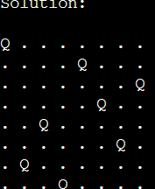

RESULT:
The Python program successfully placed all eight queens on the chessboard such that no two queens attack each other.

CONCLUSION:
The 8-Queen problem was successfully solved using the Backtracking algorithm in Python. The algorithm efficiently placed all eight queens in safe positions by checking constraints and backtracking whenever necessary, demonstrating the effectiveness of backtracking in solving AI constraint satisfaction problems.

